Project Planning Phase
Project Planning Template (Product Backlog, Sprint Planning, Stories, Story points)

Date | 13 February 2026
Team ID | LTVIP2026TMIDS35897
Project Name | BookNest : where stories nestle
Maximum Marks | 5 Marks

Product Backlog, Sprint Schedule, and Estimation (4 Marks)
Use the below template to create product backlog and sprint schedule
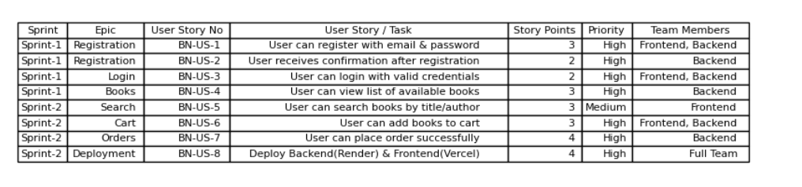

Project Tracker, Velocity & Burndown Chart: (4 Marks)
